Elephant Hill Fire: Douglas-fir Frost Sensitivity
A frost sensitivity map for Douglas-fir was generated for the Elephant Hill fire based on mapped BEC subzone/variant and site series mapping alone, and in combination, with the fire severity map for the Elephant Hill fire. The following text provides information on the GIS layers used to generate the map and how the calculations were derived to generate the final maps - one showing frost risk based on site series mapping and the other showing frost risk based on site series mapping combined with the fire severity map for the Elephant Hill fire. The former map shows the frost risk based on removal of the forest canopy whereas the second map provides an indication of frost risk based on current site conditions where it is assumed that with increasing fire severity there is a loss of forest canopy so that severely burned sites have similar site conditions to those of clearcuts.

GIS Layers Used to Generate Maps
Four GIS layers were used to generate Elephant Hill Douglas-fir frost sensitivity maps.
- A predictive ecosystem map (PEM) was completed in 2008 for the entire Cariboo Forest Region and is used as the basis for identifying site series across the landscape for the Cariboo portion of the Elephant Hill Fire. Unlike BEC maps, PEMs identify individual site series or ecosystem types across the landscape. Although, these maps are unsuitable at a site level to predict specific site series at a given point on the landscape because they cannot necessarily predict the identification of site series with a high degree of accuracy, they are useful at a landscape level to identify general areas where site series within a BEC subzone or variant are likely to occur including those where Douglas-fir may be sensitive to early spring frosts resulting in damage or death to Douglas-fir seedlings and young regen. A copy of the Cariboo PEM Final Report can be downloaded at the following link:
http://www.env.gov.bc.ca/esd/distdata/ecosystems/wis/pem/warehouse/region_5_Cariboo/Cariboo_ftp_final_5512/pem_5512_rpt.pdf

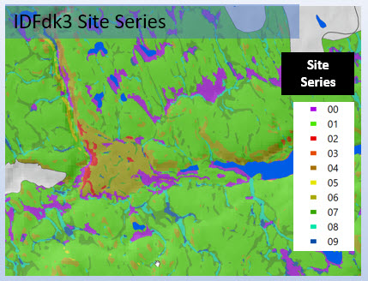
Figure 1. Portion of the Cariboo PEM for the IDFdk3 showing the distribution of site series across the landscape.

- A draft preliminary PEM of the Kamloops Timber Supply Area that encompasses the southern portion of the Elephant Hill Fire was used to identify site series and ecosystem types. Unlike the Cariboo PEM, the Kamloops map is a draft product undergoing a review and has not yet been tested for accuracy.

- GISolutions created a fire severity map of the Elephant Hill Fire based on a comparison of Landsat 8 OLI imagery before and after the fire. However, the northern portion of the map was completed before the end of the fire and is therefore not accurate. It shows a significant area of unburned area that, in fact, burned.

- A model of terrain slope based on a 25 m pixel digital elevation model (DEM) was used to identify portions of the landscape that exceeded a slope of 15%. These areas are generally less frost-prone than level to gentle areas (<= 15%) where cold air is likely to accumulate. This information was used to adjust the frost sensitivity scores applied to site series.

ArcGIS files
The ArcGIS shapefile “MERGE_FdFrostFire6” contains the data and fields used to generate two maps related to Douglas-fir frost hazard within the perimeter of the Elephant Hill fire.
The fields relevant to these maps include:
BGC_Label – BEC subzone or variant label
SiteSeries – identified BEC site series based on the classification in the of “A Field Guide to Forest Site Identification and Interpretation for the Cariboo Forest Region Land Management Handbook Number 39” (Steen and Coupé, 1997) and a updated draft classification for BEC site series within the Kamloops TSA
OldSiteSer – crosswalks the draft BEC classification for the Kamloops portion of the map to those identified in the published BEC classification for the Kamloops region described in “A Guide to Site Identification and Interpretation for the Kamloops Forest Region Land Management Handbook 23 (Lloyd et al. 1990). The site series for the Cariboo Region are the same as those identified in the field “Site Series” based on LMH Handbook No. 39.
SLOPE15 – binary field identifies whether slope exceeds 15% or is <= 15%
FdFrostSen – Frost sensitivity score for a given polygon based on identified BEC site series and SLOPE15 code. This field was used to create the map for Douglas-fir Frost Sensitivity map.
BurnSev – identifies burn severity based on categories: unburned, Low, Medium, and High
BURNCODE – numeric codes matching BurnSev catgories: 1 – unburned, 2 – Low, 3 – Medium, 4 – High
FrostXFire – resulting multiplication of the BURNCODE field and the FdFrostSen field. This field was used to create the map for Douglas-fir Frost Sensitivity based on site series and fire intensity.

Development of Douglas-fir Frost Ratings
Frost ratings were developed for each site series within each BEC subzone and variant. Information for BEC subzones and variants based in the Cariboo Region are based on silvicultural considerations outlined in Chapter 7 of “A Field Guide to Forest Site Identification and Interpretation for the Cariboo Forest Region Land Management Handbook Number 39” (Steen and Coupé, 1997). Those for BEC subzones and variants within the Kamloops TSA are based on a review of draft stocking standards and draft BEC descriptions currently under development for the Thompson-Okanagan Region. The provided Excel file provides the frost rating scores for BEC subzones and variants within the Elephant Hill fire. These scores are based on the likelihood of frost damage to Douglas-fir occurring following the removal of the overstorey vegetation (typically following clearcut logging). The sensitivity score for Douglas-fir is shown below (Table 1). Non-forested areas lack Douglas-fir and are scored a value of “0”. Conifer-dominated areas are ranked from low (1), medium (2), and high (3) in terms of risk to frost damage. Site series that are too cold to support Douglas-fir (including most site series within the ESSFxc2) are assigned a score of 100.
Table 1. Frost scores related to Douglas-fir applied to each site series
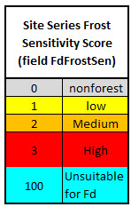
As shown in the table below, scores were adjusted for some site series depending on whether the terrain slope was greater than or less than and equal to 15%. Cold air tends to settle on level areas and gentle slopes and is therefore more likely to have a higher risk of frost than on moderate to steep slopes. Site series coloured blue in the following table are too cold to support the establishment of Douglas-fir. Scores for all site series within the Elephant Hill Fire are identified in the attached Excel file – “ranking site series by Fd frost and burn sensitivity.xlsx” of which a portion is shown below for a portion of the ESSFxc2 and IDFdk1.
Table 2. Frost Sensitivity scores assigned to each site series within the Elephant Hill area. Some scores were adjusted where the terrain slope exceeded 15%. 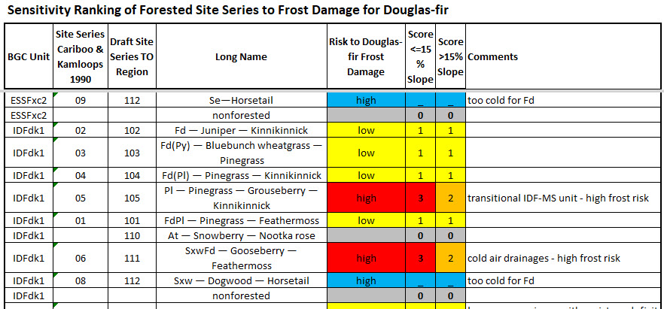
Once the Sensitivity Ranking of forested site series to frost damage for Douglas-fir was completed, the scores were applied to the Elephant Hill area based on site series and terrain slope to generate a final pdf map product showing the sensitivity ranking of forested site series to frost damage for Douglas-fir.
These scores were completed independent of the Elephant Hill burn severity map and reflect the sensitivity of the site series to frost damage based on the sensitivity of the site series to frost damage following clearcut harvesting practices.
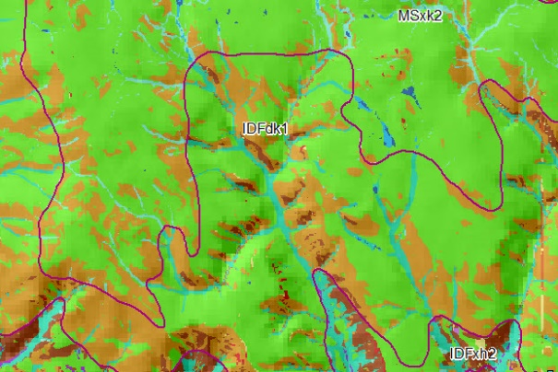
Figure 2. Portion of the PEM showing mapped site series. Green identify mesic sites, browns and reds identify dry sites sand blues and purples identify moist and wet site series.
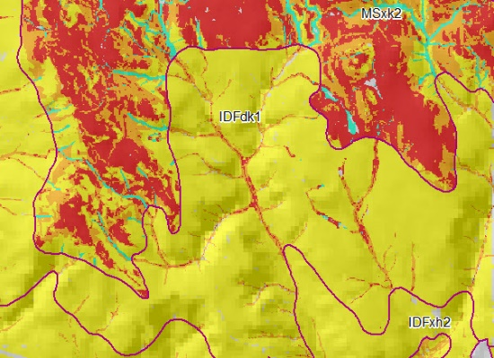
Figure 3 Portion of the PEM map shown in Figure 2 remapped to indicate Douglas-fir frost sensitivity based on the scores assigned to individual site series. Yellow areas represent site series that have low frost risk for Douglas-fir, orange medium frost risk and red high frost risk. Aquamarine areas are site series that are too cold to support Douglas-fir.

. 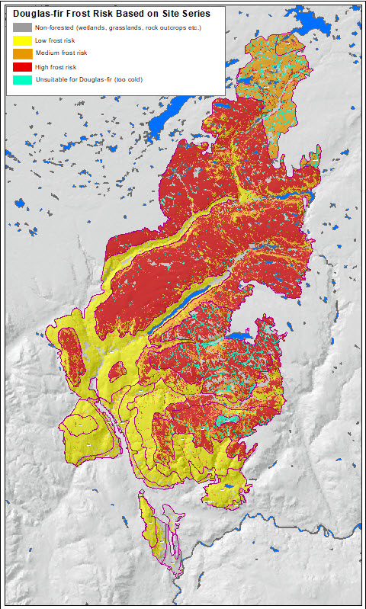
Figure 4. Completed map of Douglas-fir frost risk for the Elephant Hill fire based on site series and terrain slope.

Development of Douglas-fir Frost Ratings in Conjunction with the Elephant Hill Fire
Frost ratings of Douglas-fir were also developed in conjunction with the fire severity map where the score of the site series based on frost sensitivity was multiplied by the burn severity score at the mapped location.
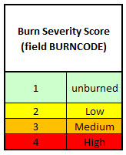

These combined frost sensitivity and burn severity scores reflect the current frost risk associated with the site before any post-fire logging activities have commenced. Unlike the previous map, they do not represent frost risk scores based on potential clearcut logging activities. Hence, sites which likely retain some canopy cover that would include unburned, low and medium severity burn areas remain less frost-prone than high severity burn areas where much or all of the canopy has been destroyed. Red areas represent areas of the landscape that likely have a significant frost risk for Douglas-fir before any salvage logging or other post-fire activities have been initiated.
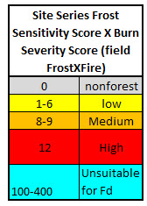
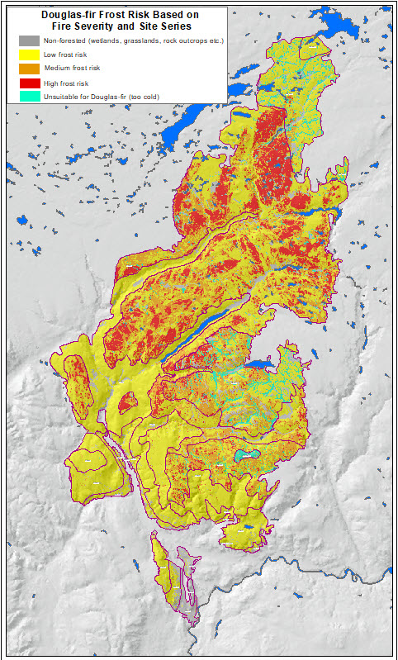
Figure 5. Frost risk for Douglas-fir based on site series, terrain slope and fire severity. Areas in red reflect areas that are severely burned and are assigned to site series where frost is a significant risk.
References
Lloyd, D., K. Angove, G. Hope, and C. Thompson. 1990. A guide to site identification and interpretation for the Kamloops Forest Region. B.C. Min. For., Victoria, B.C. Land Manage. Handb. No. 23.

Steen, O. A. and R. A. Coupé. 1997. A field guide to forest site identification and interpretation for the Cariboo Forest Region. BC. Min. For., Victoria, B.C. Land Manage. Handb. No. 39.

